Feasibility Study and Project Plan

CIS 4911 – Senior Project U01

Virtual Job Fair

**Members:**

Justin Korah

Andres Gonzalez

Tomer Doar

Diego Perez

Enmanuel Corvo

**Mentors:**

Masoud Sadjadi

Juan Caraballo

Copyright

*The contents of the Virtual Job Fair system and all associated documents belong to Florida International University and are only to be used for the purposes decided by FIU faculty. Redistribution or commercial use is prohibited without permission by the appropriate faculty in charge of the project and its contents.*

Abstract

*Virtual Job Fair seeks to aid the process of recruitment for SCIS students at Florida International University. The project attempts to connect students and companies in a more personal way than your typical job posting and application site. More particularly, the system attempts to serve as a tool for companies, especially for those who are unable to make campus visits to evaluate the talent at the university.*

*This document contains a detailed description of the project plan for the Virtual Job Fair application. It explains the limitations of the current system to introduce CIS students into the industry, and outlines the proposed solution along with the plan to achieve it. After describing the current system and the proposed solution, the document explains how the tasks are going to be organized between team members within the allotted time schedule. It analyzes what features are prioritized via a feasibility matrix. It also looks into alternative solutions that may replace the proposed features.*

Table of Contents

1. Introduction 5

1.1 Problem definition 5

1.2 Background 5

1.3 Definitions, Acronyms, and Abbreviations 6

1.5 Overview of document 6

2. Feasibility Study 7

2.1 Description of Current System 7

2.2 Purpose of New System 10

2.3 High-level Definition of User Requirements 11

2.4 Alternative Solutions 12

2.4.1 Description of Alternatives 12

2.4.2 Selection Criteria 12

2.4.3 Analysis of Alternatives 13

2.5 Recommendations 13

3. Project Plan 14

3.1 Project Organization 14

3.1.1 Project Personnel Organization 14

3.1.2 Hardware and Software Resources 14

3.2 Identification of Tasks, Milestones and Deliverables 14

4. Appendix 16

4.1 Appendix A - Project schedule 16

4.2 Appendix B – Feasibility Matrix 16

4.3 Appendix D - Diary of Meetings 17

5. References 18

# 1. Introduction

The introduction will allow the reader to understand the reasoning behind the need of the project. It will look into the problem currently faced and the limited solution that is available at the moment. It will also provide definitions, where necessary, to terminology used in this document, as well as a description of the entire document.

## 1.1 Problem definition

Recruiters everywhere are always looking for talent at the college level to fill in internship and entry level roles. Currently the most effective way for employers to recruit at schools is to visit them and set up presentations or attend career fairs at the school. Since not all employers have the resources to actively visit schools searching for talent, universities have provided career sites that enable employers to post jobs along with contact info, so that students can apply. This solution, however, is not sufficient and is not all that much different than online job boards. It is not nearly as effective as a campus visit where companies can connect with students on a face to face basis, which is what Virtual Job Fair will try to emulate.

## 1.2 Background

The Virtual Job Fair project was introduced by Dr. Masoud Sadjadi as part of the senior project class in the spring semester of 2013. A team of five students decided to take on the project as per their requirements for the curriculum. Dr. Sadjadi, along with Juan Caraballo, served as mentors for the project. Each team member focused on one specific solution that would benefit the students and employers during the recruitment process.

The senior project class (CIS 4911) is required by all computer science students for graduation. Students in this class take on various projects that are introduced either by industry representatives or school/department representatives. In this case, Dr. Sadjadi introduced this project to aid the department in assisting students with job and internship searches. Dr. Sadjadi provided the team with the problem being faced by the department and its enrolled students, and wanted the project team members to come up with possible solutions.

As requested, the team members each came up with contributions that they sought fit for the Virtual Job Fair project, as well as backup plans if necessary in case the first plan did not work out for any reason. The following table represents the first set of ideas and backup plans:

|  |  |  |
| --- | --- | --- |
| Team Member | Plan | Backup Plan(s) |
| Justin Korah | Student Job Match |  |
| Diego Perez | Auto-generated profile based on class history and skills, provided from FIU | Live Coding Competition, LinkedIn Integration |
| Andres Gonzalez | Faculty Rating | Messaging System |
| Enmanuel Corvo | Video Interview |  |
| Tomer Doar | Notification System |  |

These features will be evaluated by both Dr. Sadjadi and Juana Caraballa as the team mentors for how useful they would be to the overall purpose of the project. If needed, certain members will completely replace their plan with advice from the mentors in order to create a more meaningful and useful system.

## 1.3 Definitions, Acronyms, and Abbreviations

|  |  |
| --- | --- |
| Term | Meaning |
| CareerPath | Current career page for SCIS department, shown in www.cis.fiu.edu/careerpath |
| SCIS | School of Computer and Information Sciences |
| CS | Computer Science |
| FIU | Florida International University |
| IT | Information Technology |

## 1.5 Overview of document

The following document provides background and context to the Virtual Job Fair project. Section two describes the current system and its limitations. It explains how the proposed system will be more effective than the current setup, and gives reasoning as to why certain features will be implemented while other ones skipped. Also, it gives a high-level view of what the system is required to do.

Section three describes how the project will be organized for its duration. It provides a schedule which should be followed for the duration of the project. Personnel, hardware, and software requirements are presented in this section.

# 2. Feasibility Study

## 2.1 Description of Current System

The CIS department currently has a web page set up with listings of internships and jobs. This current setup is known as CareerPath and is located at [www.cis.fiu.edu/careerpath](http://www.cis.fiu.edu/careerpath). In its current implementation, the system allows companies to post jobs and internships. These postings include information about the company, a description for the open position, the expected duties, and the qualifications needed to perform in the position. It also provides an email address to contact as well as a website to refer to. The system serves a basic need but is lacking features when compared to modern job sites.

**Home page for CareerPath**

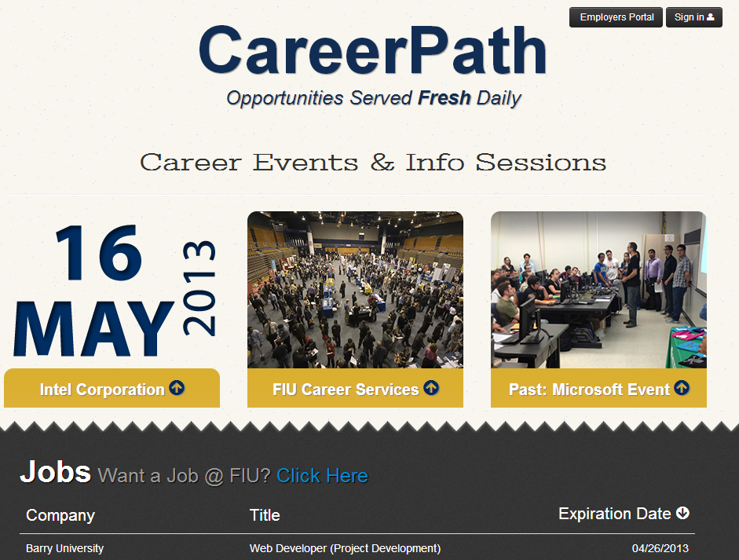

**Job list in CareerPath**

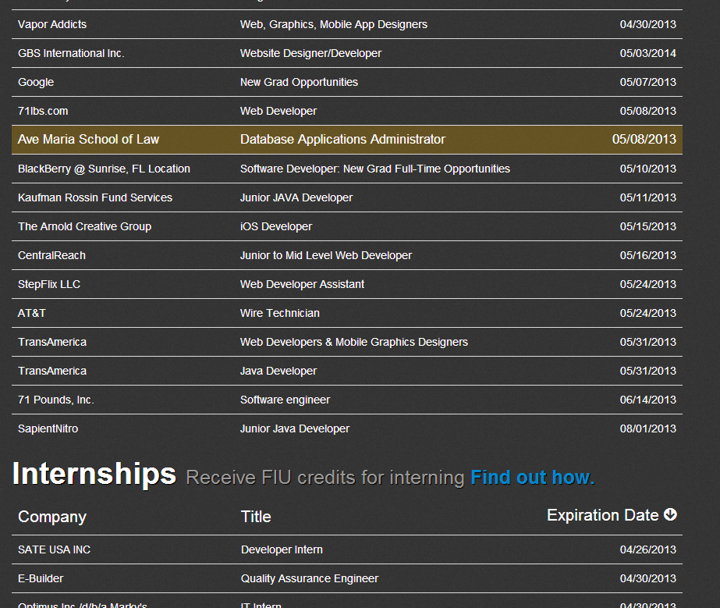

**Job description in CareerPath**

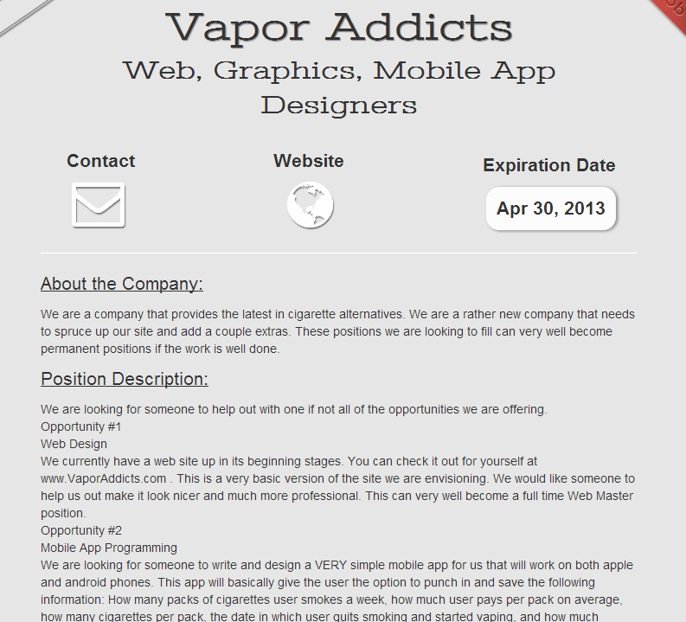

## 2.2 Purpose of New System

The new system will provide a means for students and employers to interact. The system will also provide features that optimize the recruitment process, including notifications for new opportunities and profiles to showcase student achievements. The key for success with the new system is for employers to be proactive in the talent search by using functionalities such as student job match and virtual handshakes to show interest in students.

One of the main purposes of the new system is to allow employers to connect with students without visiting the campus. Although it is obvious that visits to the campus are extremely effective, many companies simply do not have the resources and time to visit the countless campuses across the country. Virtual Job Fair provides a way for students to get noticed, not only by their resume, but by their face and personality through their profiles and hopefully through a video interview.

## 2.3 High-level Definition of User Requirements

The system shall…

* Allow students and employers to register.
* Allow students and employers to edit their basic profile information.
* Allow students and employers to take part in a video interview.
* Allow students to upload a resume.
* Allow students to associate skills to their profile.
* Allow students to integrate with their LinkedIn account to provide education and experience information
* Allow students to apply to open job postings and provide a cover letter.
* Allow students to reply to an employer’s message.
* Allow students to generate an optional student profile based on FIU class history and GPA.
* Allow employers to post jobs.
* Allow students to close a job posting.
* Allow students to associate skills to a job posting.
* Allow employers to search for students based on skills.
* Allow employers to view student profiles.
* Allow employers to send messages to students.
* Allow employers to give students a “virtual handshake” to show interest in the student.
* Allow an administrator to disable an account.
* Allow an administrator to close a job posting.
* Allow an administrator to validate an employer registration.
* Allow a faculty member login to the system.
* Allow a faculty member to give ratings to students.
* Require a username and password to log into the system
* Encrypt the user password before storing into the database
* Require login before viewing user profiles
* Use parameterized queries to take measure against SQL injection

## 2.4 Alternative Solutions

### 2.4.1 Description of Alternatives

**1-Replace difficult features**

**Due to the allotted time only being 3 months, it may be hard to implement certain features, such as the live video interviewing. Due to this risk, the following alternatives are proposed to replace the features:**

* **Online Coding Competition**

**An online compiler can be integrated into the system so that all students are able to solve and submit programming tasks posted by employers.**

**2-Replace less useful features**

* **Faculty-given rating of students**

**After a meeting with mentors it was found that this feature was not fully warranted**

### 2.4.2 Selection Criteria

When analyzing the online video interview solution based on the Schedule Feasibility criteria, it was found that this feature has the potential to be too complex to be fully implemented, because of media server requirements, synchronization issues, and cross-browser-compatibility. Because of this, we proposed alternative solution #1.

Alternative solution #1 meets the Schedule Feasibility criteria because of the already implemented online compilers that can be found in the open source community. Based on the team experience, this would not be harder to implement into our system than the online video interview.

The other feasibility criteria used to analyze alternative solution #1 was Operational Feasibility. An online coding competition is able to showcase individual student’s programming capabilities, therefore giving employers a way to distinguish exceptional students from the rest. This satisfies one of the main requirements of our system: Enable employers to search for talent at the school. It also represents a feature not found in current job fair sites.

### 2.4.3 Analysis of Alternatives

Refer to Appendix C

## 2.5 Recommendations

By researching and analyzing the requirements for the system, our team concludes that the application should be finished by the given deadline. Our team will not discard the opportunity to implement new features moving forward but will also consider eliminating some features if we find them unnecessary or redundant.

# 3. Project Plan

## 3.1 Project Organization

### 3.1.1 Project Personnel Organization

|  |  |  |
| --- | --- | --- |
| **Team Member** | **Primary Task** | **Other Task** |
| Justin Korah | Skill-based Student Job Match | General Functionality |
| Andres Gonzalez | Messaging System | General Functionality |
| Tomer Doar | Notification and Email System | General Functionality |
| Diego Perez | LinkedIn Integration and video resume | General Functionality |
| Enmanuel Corvo | Video Interview | General Functionality |

### 3.1.2 Hardware and Software Resources

Hardware

* Windows desktops and laptops
* Apple MacBook Pro laptops
* Panasonic Projector (team collaboration)

Software

* Eclipse Juno
* Scientific Linux Release 6.1
* Subversion v1.7
* Subclipse v1.0.7
* Apache v.2.2.15
* MySQL Workbench v5.2.45
* MySQL v5.0
* Yii Framework v1.1.13
* PHP v5.3.3
* Selenium v2.28

## 3.2 Identification of Tasks, Milestones and Deliverables

Refer to Appendix A for Gantt Chart

|  |  |  |
| --- | --- | --- |
| Task Name | Start Date | Due Date |
| Gather Requirements | 01/14/13 | 01/25/13 |
| Requirement Analysis | 01/24/13 | 01/28/13 |
| Setup Solution Stack | 01/21/13 | 01/28/13 |
| Deliverable 1 | 01/28/13 | 02/04/13 |
| Database Design and Setup | 01/28/13 | 02/11/13 |
| System Design | 02/11/13 | 02/25/13 |
| Deliverable 2 | 02/11/13 | 02/25/13 |
| Implementation of General Functionality | 02/25/13 | 03/15/13 |
| Implementation of Individual Features | 03/04/13 | 04/04/13 |
| Deliverable 3 | 03/22/13 | 04/04/13 |
| Test Case Write-up | 03/29/13 | 04/05/13 |
| Test Case Execution | 04/05/13 | 04/12/13 |
| Deliverable 4 | 04/04/13 | 04/19/13 |
| Code Improvement | 04/13/13 | 04/25/13 |

|  |  |
| --- | --- |
| Milestone Name | Expected Date |
| Requirements Complete | 02/04/13 |
| System Design Complete | 02/25/13 |
| Implementation Completed | 04/04/13 |
| Documentation Completed | 04/19/13 |
| Project Completed | 04/26/13 |

# 4. Appendix

## 4.1 Appendix A - Project schedule

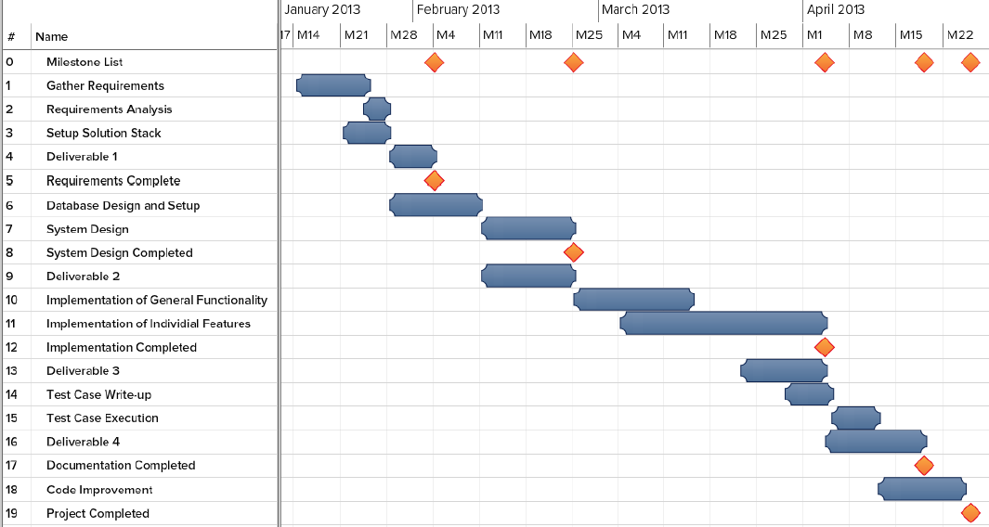

## 4.2 Appendix B – Feasibility Matrix

|  |  |
| --- | --- |
| Operational Feasibility | The scope of the proposed system covers each of the problems outlined in section 1.2. Each feature of the overall solution is specifically targeted to one of the outlined problems. This observation, together with the mentors’ validation of the proposed system, makes it operationally feasible. |
| Technical Feasibility | All the resources needed to develop the proposed system (refer to section 3.1.2) are available to the project team. Furthermore, the practicality of the technologies used (e.g., php, apache) has been proven based on their widespread use both in industry and academia, in small and large enterprise projects. |
| Schedule Feasibility | Due to graduation requirements, it is not possible to extend the project deadlines; they have to be met. The project team and the mentors have agreed on the feasibility of the proposed system based on the time requirements. |
| Economic Feasibility | There will be no development costs to the team given the open sourced nature of the technologies that are going to be used. |

## 4.3 Appendix D - Diary of Meetings

|  |  |  |
| --- | --- | --- |
| Date | Activities | Participants |
| 01/08/2013 | Outlined the problem and potential solution | Every member of the team |
| 01/12/2013 | Decided on the solution and associated features to individual team members | Every member of the team |
| 01/15/2013 | Identified the main user requirements at a high level | Every member of the team |
| 01/19/2013 | Identified the HW/SW requirements and came up with alternative solutions/features to the overall problem | Every member of the team |
| 01/22/2013 | Identified the main tasks and milestones. Also worked on 1st deliverable documentation | Every member of the team |
| 01/26/2013 | Worked on 1st deliverable documentation | Every member of the team |

# 5. References

None.